**Ethernet issue on GPU machine**

Step 1: go to link: <https://forums.linuxmint.com/viewtopic.php?t=361836>

Step2:

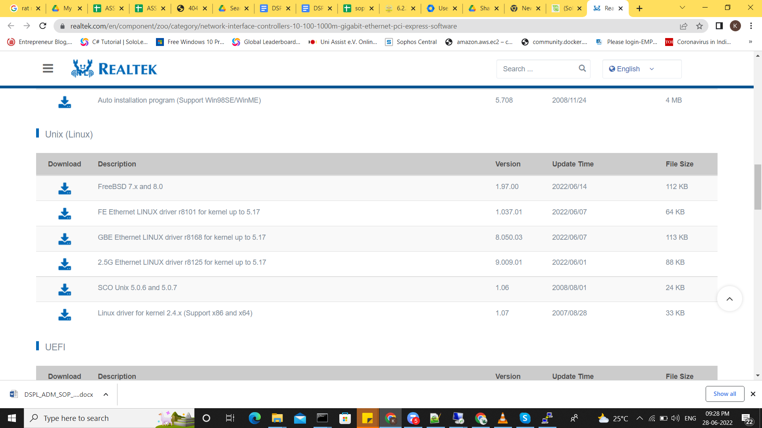

Step3 : 2.5G Ethernet Linux driver r8125 for kernel upto 5.17

Step4 : tar -xvf filename

Step5 : ./autorun.sh